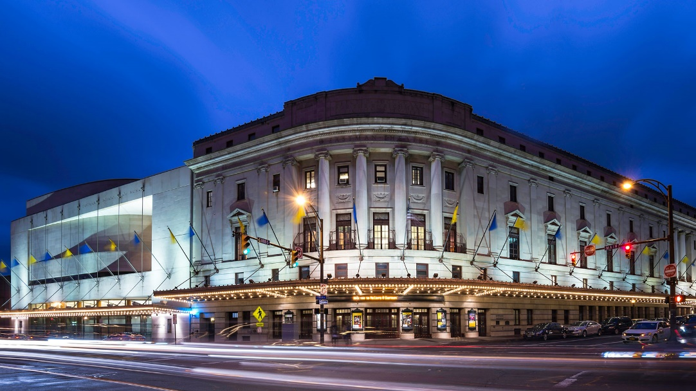

MINIMUM CAPACITY :-

The Minumum intake capacity

of students is between 300-620

children

LIBRARY :-

The Libarary is Available.

CANTEEN:-

The Canteen Facility is Available.

BOARDING :-

No availablility of boarding.

SPORTS :-

There are different categories

sports available.

Girls Volleyball

Boys Volleyball

Football

|  |  |  |
| --- | --- | --- |
| EASTMAN COMMUNITY MUSIC SCHOOL  ROCHESTER - SCHOOL |  |  |
|  |  |  |
| School Detail :- We believe that music is not only an essential part of a quality education, but also a powerful contributor to quality of life. George Eastman created the Eastman Community Music School (ECMS) in 1921 for the enrichment of the residents of greater Rochester with the expectation that this experience should be available to everyone, regardless of age, musical background or ability to pay.  Excellence, creativity, diversity, and joy are a few words that best describe teaching and learning at the Eastman Community Music School. |  |
|